# **Head end Sub-system**

**Introduction -**

The head end or the front end system is the heart of the network and the source of all signals. A considerable amount of funds are invested in the Headend and the network owner needs to keep in mind both, his existing needs as well as project and consider his future requirements.

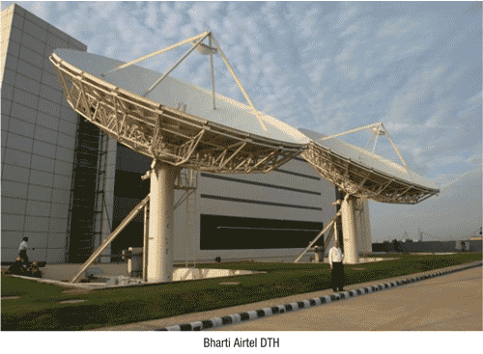

Front-end system consists of video and audio compression encoders, multiplexers and other components. The main task is to front-end system for digital TV signal coding, the use of statistical multiplexing technology in a limited frequency band to transmit more programs. The MPEG-2 compressed video and audio signals received from the broadcasters are converted to MPEG-4 which are further processed and integrated with the software and then sent to the RF sub-station for unlinking.

**Network Elements -**

The headend facility comprises of two main systems –

* Content acquisition system
* Compression system

**Content acquisition system -**

The content acquisition system is the where the data signals are received from the broadcaster and passed on for processing.

Receiving antennae:

The receiving antennae at the headend facility acquire the data transmitted by the broadcaster in the L band frequency.

The Airtel DTH uplink facility at Manesar has a number of 4.5m dishes for receiving signals. The size of the receiving antennae varies as per the frequency band of transmission.

IRD :

An integrated receiver/[decoder](http://decoder) (IRD) is an electronic [device](http://circuit) used to pick-up a radio-frequency signal and convert [digital](http://digital) information transmitted in it. The IRD is used for the reception of contribution feeds that are intended for re-broadcasting, and forms the interface between a receiving [satellite dish](http://dish) and the uplink infrastructure.

Routers :

Video Routers are used for transporting video signals from inputs to outputs. The number of inputs and outputs varies dramatically. The way routers are described is normally number of inputs by number ofoutputs e.g. 2x1, 256x256. Because any of the inputs can be routed to any output, the internal arrangement of the router is arranged as a number of crosspoints which can be activated to pass the corresponding signal to the desired output.

Video Router

Receiving Antennae

IRD and L band Splitter

**Compression System -**

The Compression system takes the signals from the content acquisition system and begins processing through various stages with the addition of the middleware and applications.

MPEG-4 encoder:

The data sent by the broadcaster is encoded in MPEG-2 format and is converted into the more efficient MPEG-4 format. For optimized use of broadcast channel it is necessary to reduce the amount of data that is necessary to transport specific information. Higher compression allows us to transport more information within a given bit rate. DTH bit rates are comparatively low, enabling MPEG4 to achieve its greatest efficiency and advantage over MPEG-2. DTH applications do not normally worry about encoder/decoder latency, which is critically important for encoder performance.

The DVB S2 is a [digital television](http://television) broadcast standard that has been designed as a successor for the popular [DVB-S](http://dvb-s) system. The MPEG-4 encoding can be coupled with the efficiency offered by DVB-S2 modulation to provide consistence picture quality in even the worst weather conditions.

MPEG-4 is also being used by various DTH providers to offer new HD services to customers.

Multiplexer:

The multiplexer in the DTH system plays the role of mixing all the incoming channels (not to be confused with TV channels) into a single signal at a particular frequency. Here, all the processing of the signal begins, with integration of all the software and applications that come as part of the DTH services.

Modulator:

Modulators essentially take an input signal and attach it to a specific frequency.Modulation is essential for transmission of two or more signals simultaneously. Modulation avoids any interference between the two signals and also ensures that signal errors are avoided during transmission. It entails the transformation of data using error correction and signal mapping to produce a digital carrier suitable for satellite transmission.

Modulator

Multiplexer

MPEG-4 Encoder

**Need and Type of Capex -**

The headend is a master facility for receiving signals from the broadcaster for processing and distribution over the DTH system. As a vital element in the functioning of the DTH system, capital expenditure is made to upgrade the headend as per business requirements.

* **Technical Equipment –**

Capex is required for equipment & instruments to optimize the working of the system.

Installation of new equipment increased heat dissipation in the CAS room. With the current 3.8 TR precision AC proving insufficient, a new 6.5 TR PAC (precision air conditioner) was required to maintain the recommended temperature.

Initial Investment includes -

**Cost of new component:**

Precision Air Condition (25 Kw) with HSC, FSC, NIC card

**Additional equipment and Accessories:**

Refrigerant etc.

**Peripherals and cabling:**

Copper piping electrical cabling and copper pipe insulation

**Installation and commissioning charges**

**Project Management Fee**

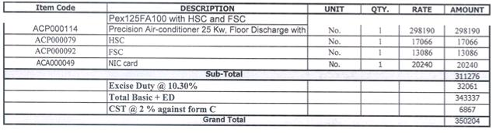

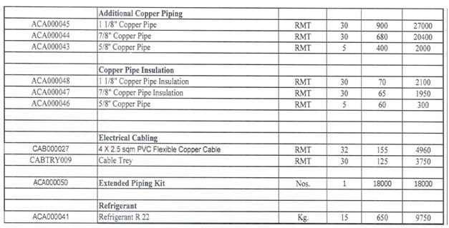

* **Addition of new functionalities in the system -**

Addition, Up-gradation and testing of new functionalities in the system is an ongoing process to improve services.

The NDS test System for videoguard headend of DTH was implemented to enable testing of upgrades and new functionalities before putting on live system.

Costs Involved -

**Cost of new equipment:**

VG Cluster (security server base infra and boards)

VG Module (Webservers, ASI isStreamer)

**Add on products and other accessories:**

OIG (Optional Catoris), Synamedi8 XTV Encryptor, Synamedia XTVS (CAB/PAS), iSSH Boards (with 24 chips)

**Installation of software:**

VGH Management Client PC, Antivirus Enterprise Windows Clients

**Racking and peripherals:**

BackuPDiSkS, 1 Blade Base Entry Crate

**Project Management Fee**

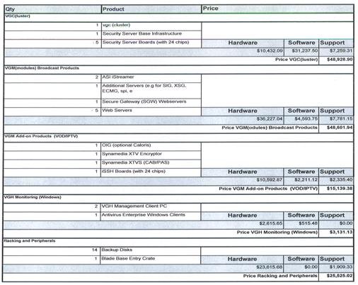

* **New Revenue Opportunity –**

Investment is required to undertake new projects and development to explore newer avenues to generate revenue and make the services that are attractive, robust and more than meet the expectation of end Customer.

Audience Measurement System (AMS) is an end-to-end system that enables DTH operator to measure subscriber-viewing behavior. AMS provides events information related to the whole TV viewing experience, including live viewing; recording, local playback, interactive applications messages, and reports the log events in a non-intrusive mode. The DTH headend was upgraded to support the Audience Measurement System (AMS), which is a functional set of EPG phase 3.0. AMS integration was undertaken by NDS, Airtel’s technology partner for EPG and CAS system

The cost involved in such an investment goes as follows –

**Cost of new components and hardware:**

iChannel (New Component)

AMS Proxy (New Component)

VG Console (Existing Component, Only upgrade)

EMMG (Existing Component, Only upgrade)

**Cost of Installation of hardware and software:**

Installation of new head end machines for AMS including: hardware, software and configuration

Modification of existing NOS Videoguard head end component configuration to support AMS and GSM functions

**Cost of Integration with the system:**

Integration with GSM Return Path Network

Integration with 3rd· party recipients of AMS Data

**Project Management Fee**

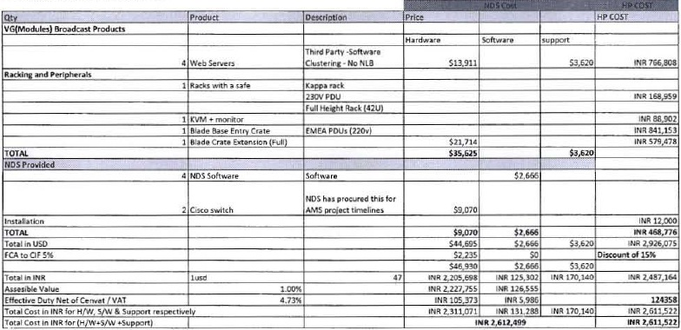

* **Investment to support growth -**

A large scale capital expenditure may be required to enable the company to expand and bring about extensive changes in the system.

Upgradation of headend Satellite migration:

Migration to a new satellite SES-7 from INSAT 4CR was undertaken to meet business requirement. This was accompanied by Technical Infrastructure & Headend system upgradation at Manesar for SES 7.

**Note:** Large scale projects undertaken by the company such as Satellite Migration involve heavy Capital Expenditure and Operational Expenditure covering a major part of the system and spanning over a number of years. Hence, its effect can be seen throughout the system.

The following table shows the cost of activities during migration to 2nd Satellite.

|  |  |
| --- | --- |
| Activity | Cost in Mn |
| CAS integration (Bangalore) | 33.50 |
| IT and Connectivity infrastructure (Bangalore) | 1.30 |
| NMS and Monitoring Services (Bangalore) | 17.83 |
| Headend Up gradation (Manesar) | 55.74 |
| RF sub system upgrade (Bangalore) | 56.81 |